Ex.No: 4.a | EDA– DATA INSPECTION, FILTERING, STATISTICAL ANALYSIS AND CORRELATION
Aim:

Algorithm:
Step1: Start.
Step2:Import the required libraries
Step3 Load the dataset into a pandas DataFrame.
Step4 Display the first five rows using df.head().
Step5 Display the shape of the dataset using df.shape.
Step6 Display the data types of each column using df.dtypes.
Step7 Filter records based on a condition (e.g., Marks > 85 or Age > 50).
Step8 Filter records belonging to a specific category (e.g., Department or Disease).
Step9 Sort the dataset using df.sort_values().
Step10 Calculate statistical measures:
- Mean
- Median
- Mode
- Standard Deviation
Step11 Display summary statistics using df.describe().
Step12 Group the data using groupby() and calculate the average.
Step13 Find the correlation between numerical columns using corr().
Step14 Create a Scatter Plot using Matplotlib.
Step15 Create a Bar Plot using Matplotlib.
Step16 Display the graphs.
program:

import pandas as pd
import matplotlib.pyplot as plt

# Create DataFrame
data = {
"Roll No": [101,102,103,104,105,106],
"Name": ["Arun","Bala","Divya","Priya","Ravi","Karthik"],
"Department": ["CSE","IT","CSE","AI&DS","IT","AI&DS"],
"Marks": [85,78,95,90,72,88],
"Attendance": [92,88,96,94,85,91]
}

df = pd.DataFrame(data)

# View Data
print("First 5 Rows")
print(df.head())

print("\nShape")
print(df.shape)

print("\nData Types")
print(df.dtypes)

# Filter Marks > 85
print("\nStudents with Marks > 85")
high_marks = df[df["Marks"] > 85]
print(high_marks)

# Filter IT Department
print("\nIT Department Students")
it_students = df[df["Department"] == "IT"]
print(it_students)

# Sort by Marks
print("\nSorted by Marks")
sorted_df = df.sort_values(by="Marks", ascending=False)
print(sorted_df)

# Statistics
print("\nMean =", df["Marks"].mean())
print("Median =", df["Marks"].median())
print("Mode =")
print(df["Marks"].mode())
print("Standard Deviation =", df["Marks"].std())

# Summary
print("\nSummary Statistics")
print(df.describe())

# Group By
print("\nAverage Marks by Department")
dept_avg = df.groupby("Department")["Marks"].mean()
print(dept_avg)

# Correlation
print("\nCorrelation")
corr = df[["Marks","Attendance"]].corr()
print(corr)

# Scatter Plot
plt.scatter(df["Attendance"], df["Marks"])
plt.title("Marks vs Attendance")
plt.xlabel("Attendance")
plt.ylabel("Marks")
plt.grid(True)
plt.show()

# Bar Plot
dept_avg.plot(kind="bar")
plt.title("Average Marks by Department")
plt.xlabel("Department")
plt.ylabel("Average Marks")
plt.show()
Output:

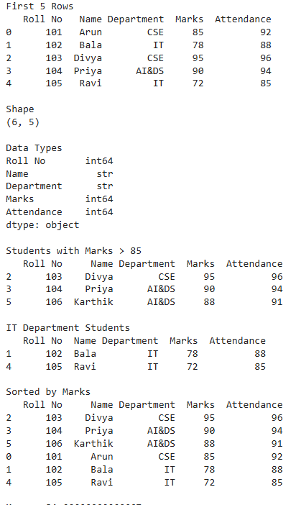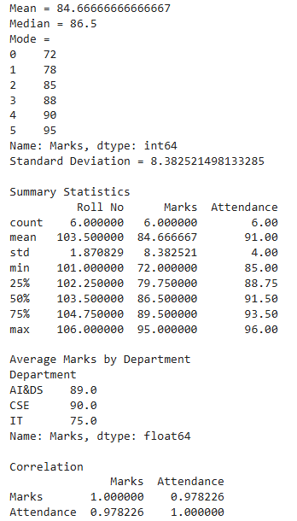
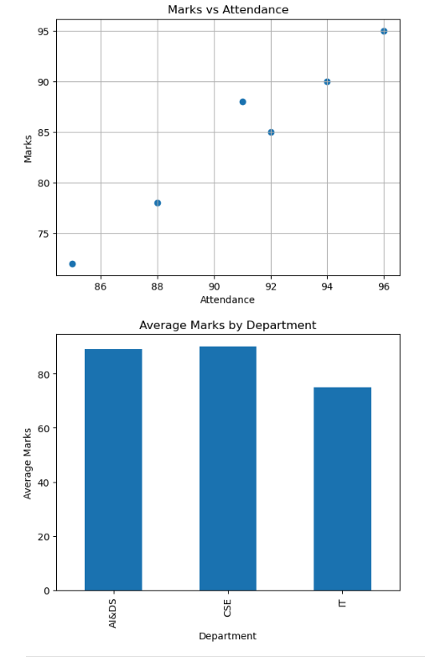

Result:

Ex.No:4.b | EDA– DATA INSPECTION, FILTERING, STATISTICAL ANALYSIS AND CORRELATION
Aim:

Algorithm:
Step1: Start.
Step2:Import the required libraries
Step3 Load the dataset into a pandas DataFrame.
Step4 Display the first five rows using df.head().
Step5 Display the shape of the dataset using df.shape.
Step6 Display the data types of each column using df.dtypes.
Step7 Filter records based on a condition (e.g., Marks > 85 or Age > 50).
Step8 Filter records belonging to a specific category (e.g., Department or Disease).
Step9 Sort the dataset using df.sort_values().
Step10 Calculate statistical measures:
- Mean
- Median
- Mode
- Standard Deviation
Step11 Display summary statistics using df.describe().
Step12 Group the data using groupby() and calculate the average.
Step13 Find the correlation between numerical columns using corr().
Step14 Create a Scatter Plot using Matplotlib.
Step15 Create a Bar Plot using Matplotlib.
Step16 Display the graphs.
Program:
import pandas as pd
import matplotlib.pyplot as plt
print("First 5 Rows")
print(df.head())
print("\nShape")
print(df.shape)
print("\nData Types")
print(df.dtypes)
print("\nPatients with Age > 50")
age_filter = df[df["Age"] > 50]
print(age_filter)
print("\nPatients with Diabetes")
diabetes_patients = df[df["Disease"] == "Diabetes"]
print(diabetes_patients)
print("\nFemale Patients")
female_patients = df[df["Gender"] == "Female"]
print(female_patients)
print("\nSorted by Age")
sorted_df = df.sort_values(by="Age", ascending=False)
print(sorted_df)
print("\nMean Age =", df["Age"].mean())
print("Median Age =", df["Age"].median())
print("\nMode Age")
print(df["Age"].mode())
print("Standard Deviation Age =", df["Age"].std())
print("\nSummary Statistics")
print(df.describe())
print("\nAverage Age by Disease")
disease_avg = df.groupby("Disease")["Age"].mean()
print(disease_avg)
print("\nCorrelation")
corr = df[["Age", "Blood_Sugar"]].corr()
print(corr)
plt.figure(figsize=(6,4))
plt.scatter(df["Age"], df["Blood_Sugar"])
plt.title("Age vs Blood Sugar")
plt.xlabel("Age")
plt.ylabel("Blood Sugar")
plt.grid(True)
plt.show()
disease_avg.plot(kind="bar")
plt.title("Average Age by Disease")
plt.xlabel("Disease")
plt.ylabel("Average Age")
plt.show()

Output:
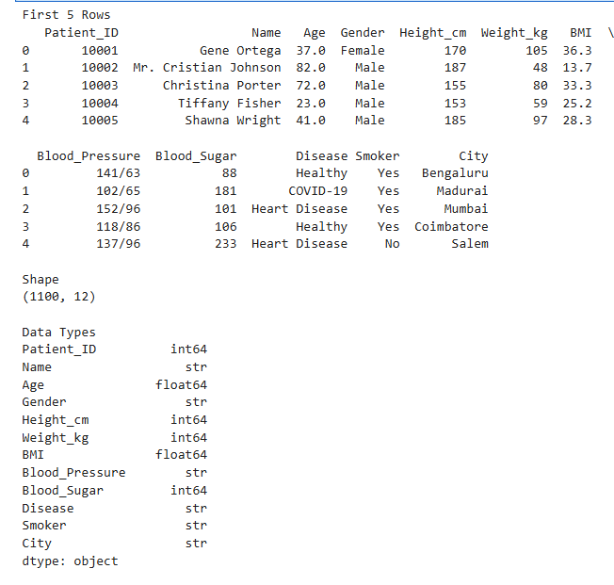
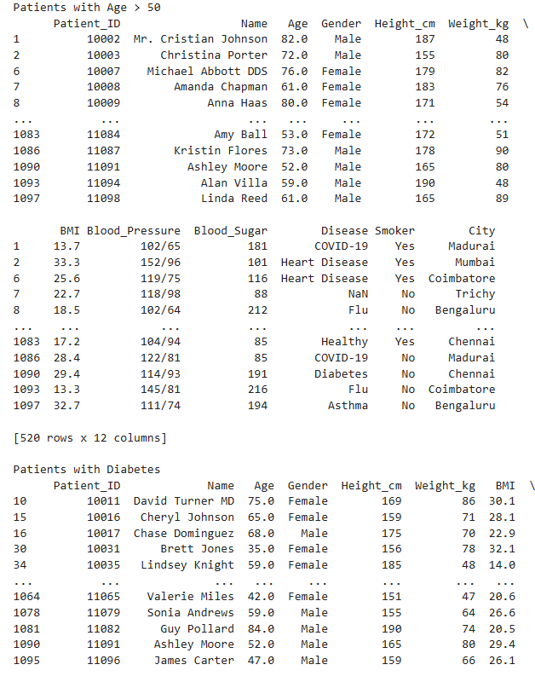

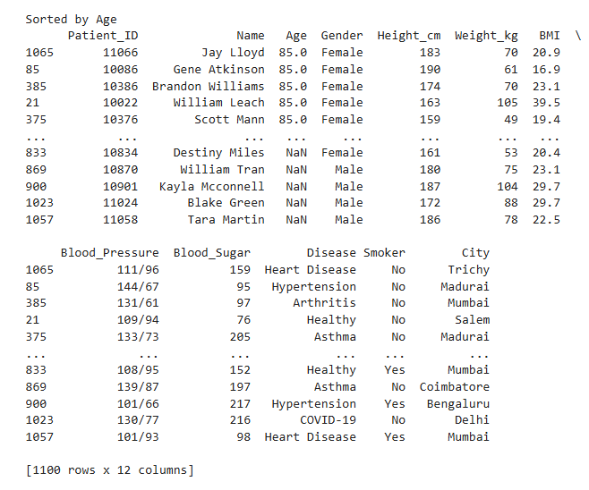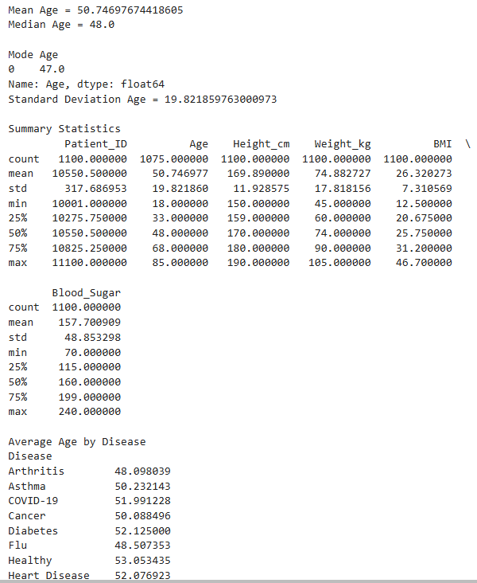
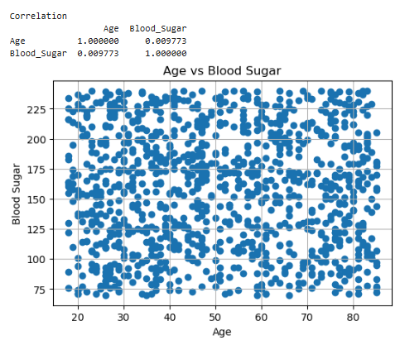 ReR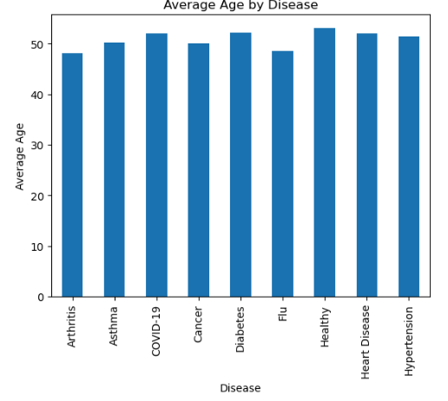
Result:

